GNU Octave, version 3.8.2
Copyright (C) 2014 John W. Eaton and others.
This is free software; see the source code for copying conditions.
There is ABSOLUTELY NO WARRANTY; not even for MERCHANTABILITY or
FITNESS FOR A PARTICULAR PURPOSE. For details, type 'warranty'.

Octave was configured for "i586-pc-linux-gnu".

Additional information about Octave is available at http://www.octave.org.

Please contribute if you find this software useful.
For more information, visit http://www.octave.org/get-involved.html

Read http://www.octave.org/bugs.html to learn how to submit bug reports.
For information about changes from previous versions, type 'news'.

a = 1.000000
l = 1.000000
T = 0.050000

ε =
1.0000e-10

Параметры сетки:
n = 16
k = 8

hx = 0.062500
ht = 0.006250

Начальное возмущение =
@(x) 0.1 * sin (2 * pi * x)

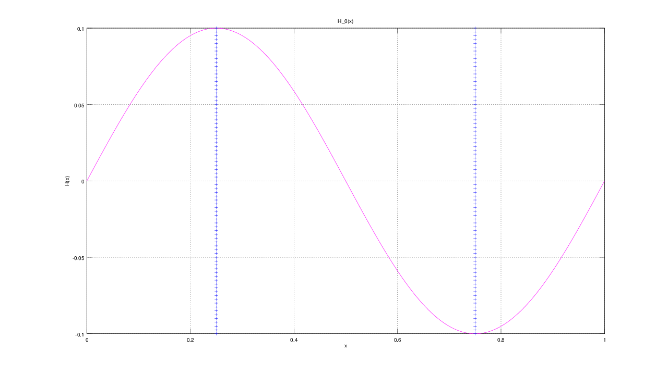
Всего демпферов: 2

Демпфер # 1

x_1 = 0.250000

Верхнее предельное значение w_1(t) =
NaN

Нижнее предельное значение w_1(t) =
NaN

Управляющая функция w_1(t):
74.310
-117.535
84.513
-114.621
183.456
-114.299
259.001
-217.964
278.669

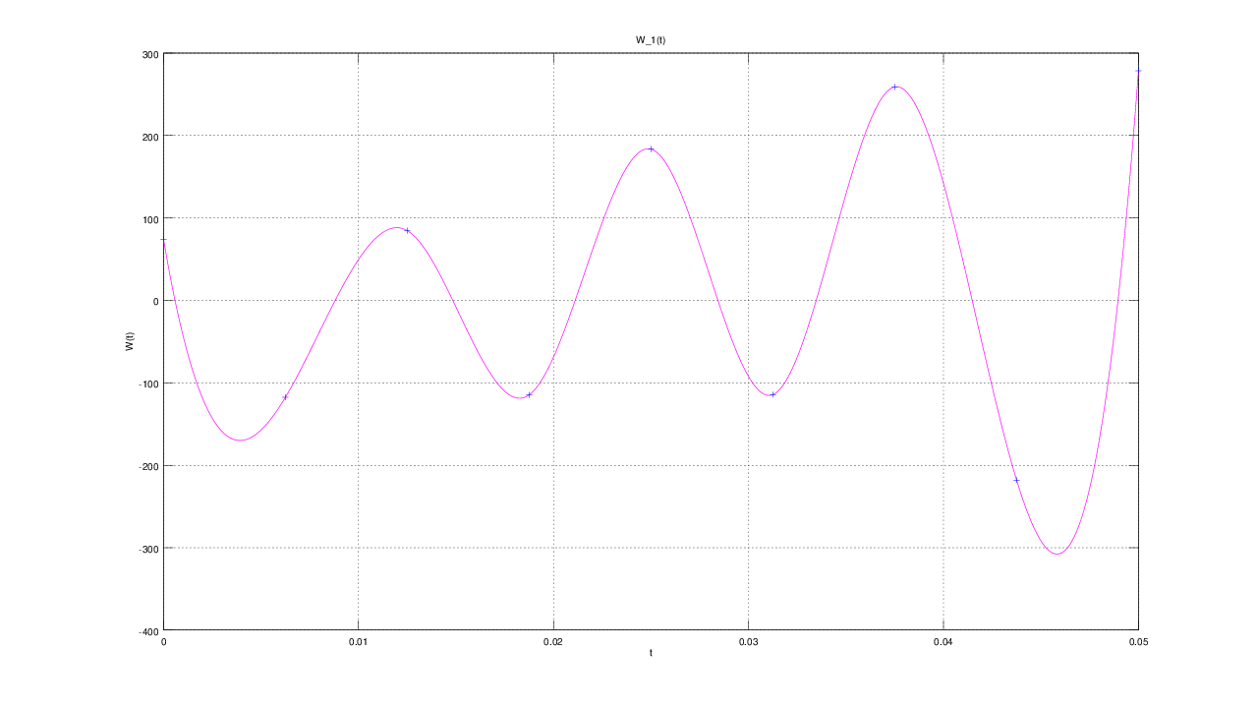

Демпфер # 2

x_2 = 0.750000

Верхнее предельное значение w_2(t) =
NaN

Нижнее предельное значение w_2(t) =
NaN

Управляющая функция w_2(t):
361.58
-318.38
351.43
-321.37
252.59
-321.82
177.21
-218.34
157.73

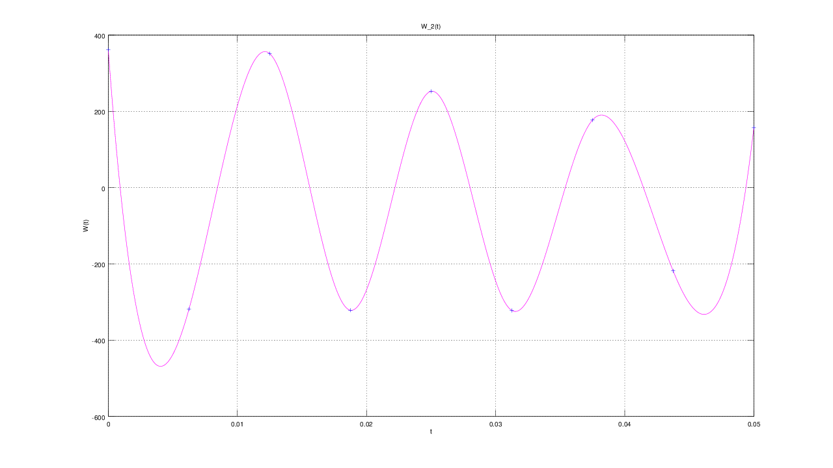

E(T) =
4.0473e-10

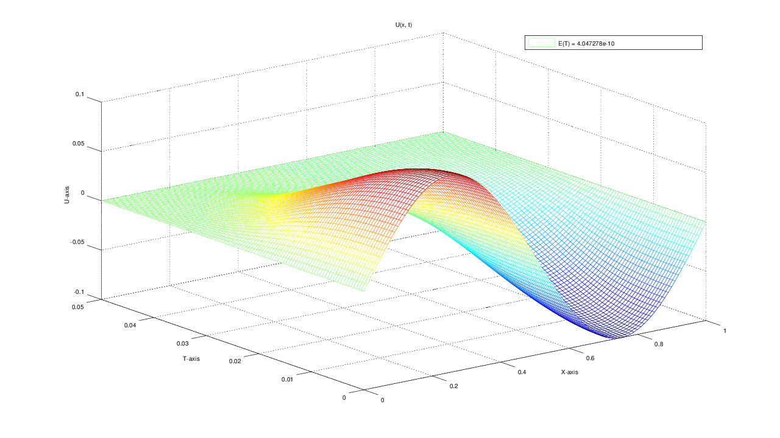
u(x, t)
T = 0.000000: 0.000000 0.038268 0.070711 0.092388 0.100000 0.092388 0.070711 0.038268 0.000000 -0.038268 -0.070711 -0.092388 -0.100000 -0.092388 -0.070711 -0.038268 -0.000000
T = 0.006250: 0.000000 0.037100 0.068160 0.088081 0.094111 0.088081 0.068160 0.037100 0.000000 -0.037100 -0.068160 -0.088082 -0.094112 -0.088082 -0.068160 -0.037100 0.000000
T = 0.012500: 0.000000 0.032804 0.059358 0.075532 0.080633 0.075532 0.059358 0.032804 0.000000 -0.032804 -0.059359 -0.075533 -0.080634 -0.075533 -0.059359 -0.032804 0.000000
T = 0.018750: 0.000000 0.024160 0.044073 0.057107 0.061538 0.057107 0.044074 0.024160 -0.000000 -0.024161 -0.044074 -0.057108 -0.061539 -0.057108 -0.044075 -0.024161 0.000000
T = 0.025000: 0.000000 0.013228 0.026234 0.037024 0.042341 0.037024 0.026234 0.013227 -0.000001 -0.013229 -0.026235 -0.037025 -0.042341 -0.037025 -0.026235 -0.013228 0.000000
T = 0.031250: 0.000000 0.005021 0.011706 0.019392 0.023856 0.019392 0.011705 0.005020 -0.000001 -0.005022 -0.011707 -0.019393 -0.023858 -0.019392 -0.011707 -0.005021 0.000000
T = 0.037500: 0.000000 0.001406 0.003784 0.007359 0.010413 0.007358 0.003783 0.001405 -0.000001 -0.001407 -0.003785 -0.007360 -0.010414 -0.007359 -0.003784 -0.001406 0.000000
T = 0.043750: 0.000000 0.000352 0.000945 0.001841 0.002602 0.001840 0.000944 0.000351 -0.000001 -0.000353 -0.000946 -0.001841 -0.002602 -0.001840 -0.000945 -0.000351 0.000000
T = 0.050000: 0.000000 0.000001 -0.000001 0.000001 -0.000002 0.000001 -0.000002 -0.000001 -0.000001 -0.000002 0.000001 -0.000001 0.000002 -0.000001 0.000002 -0.000000 0.000000

